

Charging of 18650 Battery using TP4056-1s BMS

Experiment No: 01
Aim: Charging of Samsung 18650 Li-ion cell by using single-cell BMS chip battery protection board.

Software Required: Arduino IDE

Theory:

Battery Electric Vehicles (BEVs) are becoming ever more popular and in high demand. The most critical and costly element of the BEV is the battery system. In order to guarantee optimal performance, it is important to continually monitor the battery pack and the enclosed cells connected in series under all driving conditions and during battery charging.
The system with the monitoring and the development of the algorithm was a crucial role, so the system with monitoring states for various items like the voltage, temperature, coolant flow, current, the health of individual cells, and the state of balance of cells, were major aspects to look into. There are different types of BMSs that are used to avoid battery failures. The most common type is a battery monitoring system that records the key operational parameters such as voltage, current and the internal temperature of the battery along with the ambient temperature during charging and discharging. The system provides inputs to the protection devices so that the monitoring circuits could generate alarms and even disconnect the battery from the load or charger if any of the parameters exceed the values set by the safety zone parameters.
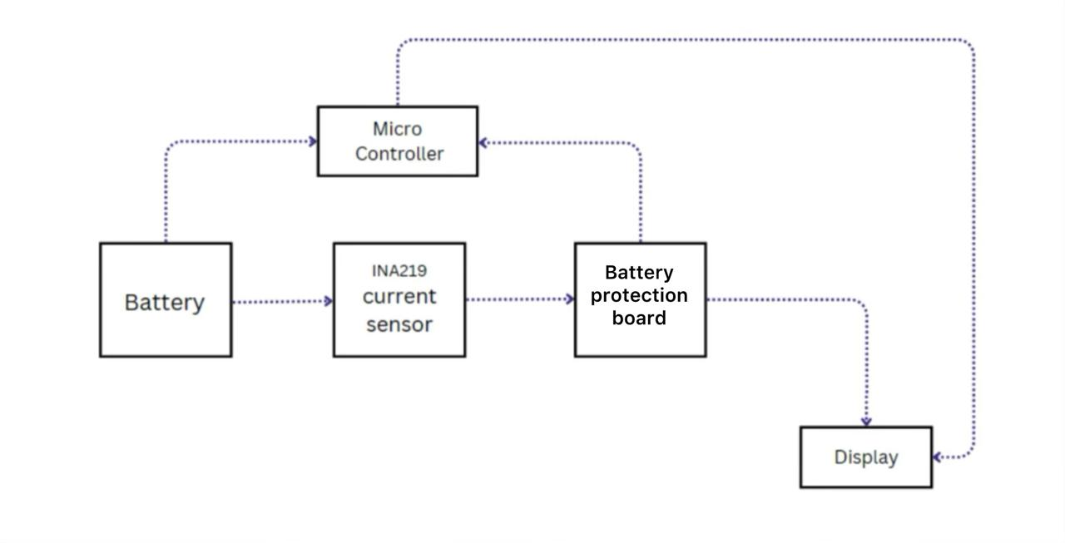

Figure: 1. Block diagram representation for 1S-BMS

Components required:

Sl.No | Component name | Qty | Link | Approx.  Price
1. | Arduino UNO/ NANO | 1 | Buy Original Arduino Nano made in Italy with 6  month brand Warranty (robu.in) | /1499
2. | CJMCU-219 INA219 I2C  Interface current sensor | 1 | Buy INA219 Bi-Directional Power Supply  Monitoring Module Online (robu.in) | 219
3. | 1.3 Inch I2C OLED Display  Module 4pin | 1 | Buy Best Quality 1.3 Inch I2C/IIC OLED LCD  Display Module 4pin- WHITE (robu.in) | 331
4. | 18650 SMD/SMT High-  Quality Single Battery Holder | 1 | Buy High Quality 18650 SMD Single Battery Holder at Low Price | Robu | 60
5. | TP4056 1A Li-ion Lithium Battery Charging Module With Current Protection –  Type C | 1 | Buy Li ion TP4056 Charging Board Type C w/ Current Protection (robu.in) | 26
6. | Samsung ICR18650-26JM 2600mAh (2C) LI-ION  BATTERY | 1 | Buy SAMSUNG 18650 26J 2600mAh Li ion  Battery Online | Robu.in | 353
7. | Type C cable | 1
8. | Connecting wires | 1 | Buy U - Shape Breadboard Jumper Kit - 140 Pcs  Online at the Best Price (robu.in) | 109
9. | Breadboard | 1 | Buy 400 Point Mini Breadboard Online at the  Best Price in India (robu.in) | 55

Circuit diagram:
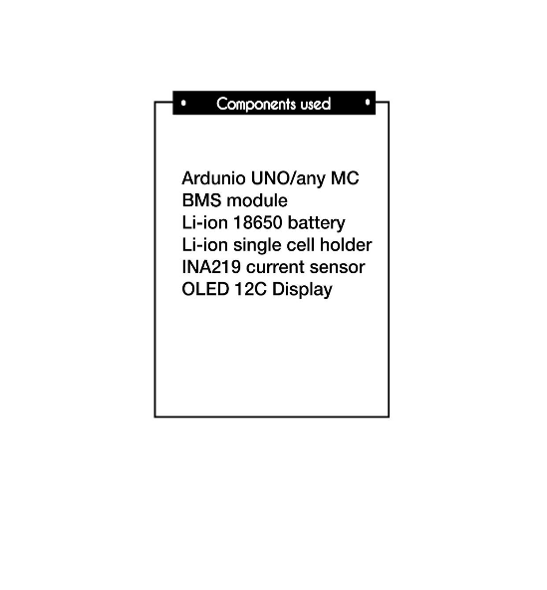
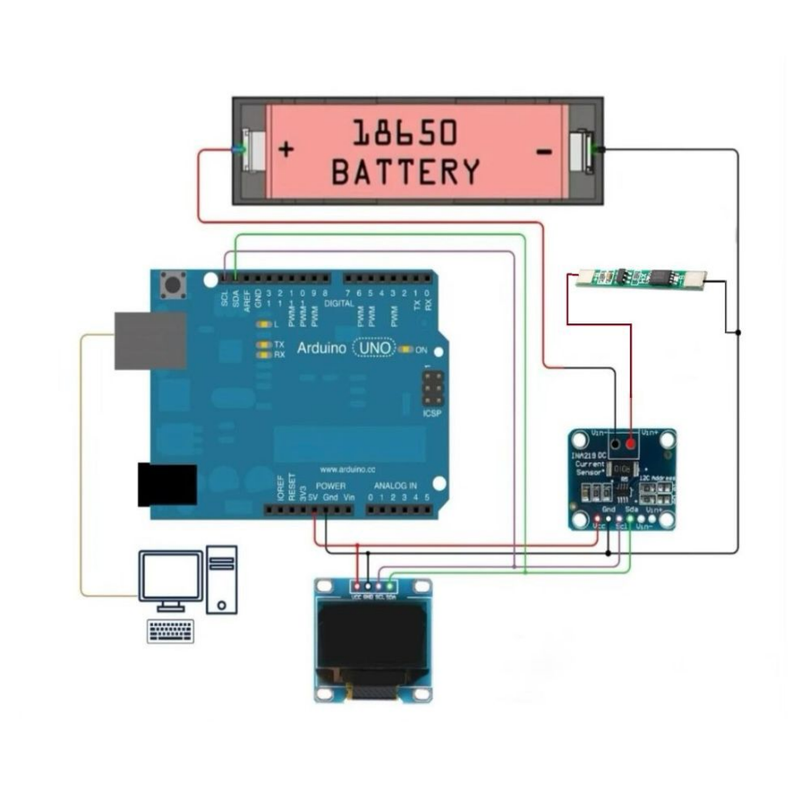
Figure: 1. Circuit diagram for 18650 charging system

Code: https://drive.google.com/file/d/1HyYRMwqKqtxfVCetkQ47HziZ5IECjNU8/view?usp=sharing Note: The code file only can accessed by using BITS email id.

Experimental results:

Sl.No | Time | Voltage | Current | Observations made
1.
2.
3.
4.
5.
6.
7.

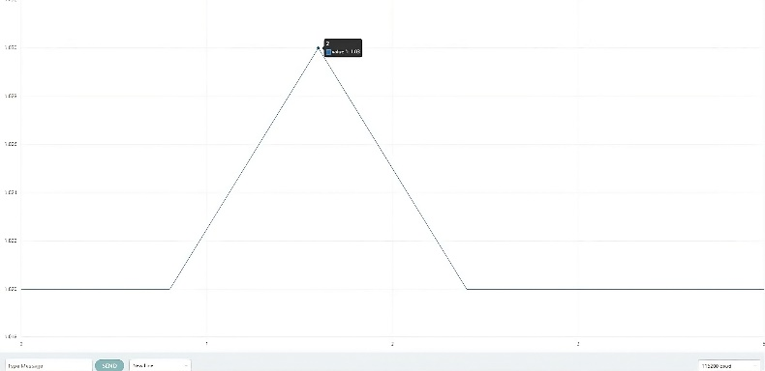
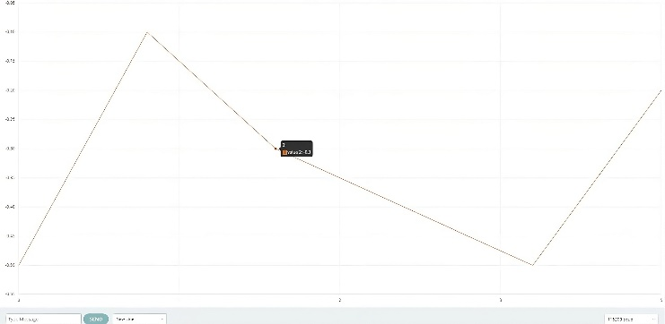

Result:



Charging of 18650 Battery using TP4056-1s BMS

Experiment No: 02
Aim: Charging of Samsung 18650 Li-ion cell by using single-cell BMS chip TP4056.

Software Required: Arduino IDE

Theory:

Battery Electric Vehicles (BEVs) are becoming ever more popular and in high demand. The most critical and costly element of the BEV is the battery system. In order to guarantee optimal performance, it is important to continually monitor the battery pack and the enclosed cells connected in series under all driving conditions and during battery charging.
The system with the monitoring and the development of the algorithm was a crucial role, so the system with monitoring states for various items like the voltage, temperature, coolant flow, current, the health of individual cells, and the state of balance of cells, were major aspects to look into. There are different types of BMSs that are used to avoid battery failures. The most common type is a battery monitoring system that records the key operational parameters such as voltage, current and the internal temperature of the battery along with the ambient temperature during charging and discharging. The system provides inputs to the protection devices so that the monitoring circuits could generate alarms and even disconnect the battery from the load or charger if any of the parameters exceed the values set by the safety zone parameters.
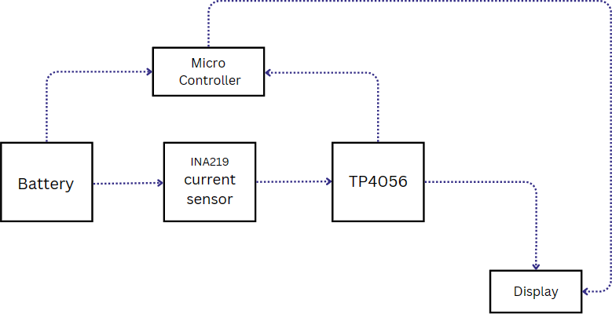

Figure: 2. Block diagram representation for 1s BMS

Components required:

Sl.No | Component name | Qty | Link | Approx.  Price
1. | Arduino UNO/ NANO | 1 | Buy Original Arduino Nano made in Italy with 6  month brand Warranty (robu.in) | /1499
2. | CJMCU-219 INA219 I2C  Interface current sensor | 1 | Buy INA219 Bi-Directional Power Supply  Monitoring Module Online (robu.in) | 219
3. | 1.3 Inch I2C OLED Display  Module 4pin | 1 | Buy Best Quality 1.3 Inch I2C/IIC OLED LCD  Display Module 4pin- WHITE (robu.in) | 331
4. | 18650 SMD/SMT High-  Quality Single Battery Holder | 1 | Buy High Quality 18650 SMD Single Battery Holder at Low Price | Robu | 60
5. | TP4056 1A Li-ion Lithium Battery Charging Module With Current Protection –  Type C | 1 | Buy Li ion TP4056 Charging Board Type C w/ Current Protection (robu.in) | 26
6. | Samsung ICR18650-26JM 2600mAh (2C) LI-ION  BATTERY | 1 | Buy SAMSUNG 18650 26J 2600mAh Li ion  Battery Online | Robu.in | 353
7. | Type C cable | 1
8. | Connecting wires | 1 | Buy U - Shape Breadboard Jumper Kit - 140 Pcs  Online at the Best Price (robu.in) | 109
9. | Breadboard | 1 | Buy 400 Point Mini Breadboard Online at the  Best Price in India (robu.in) | 55

Circuit diagram:

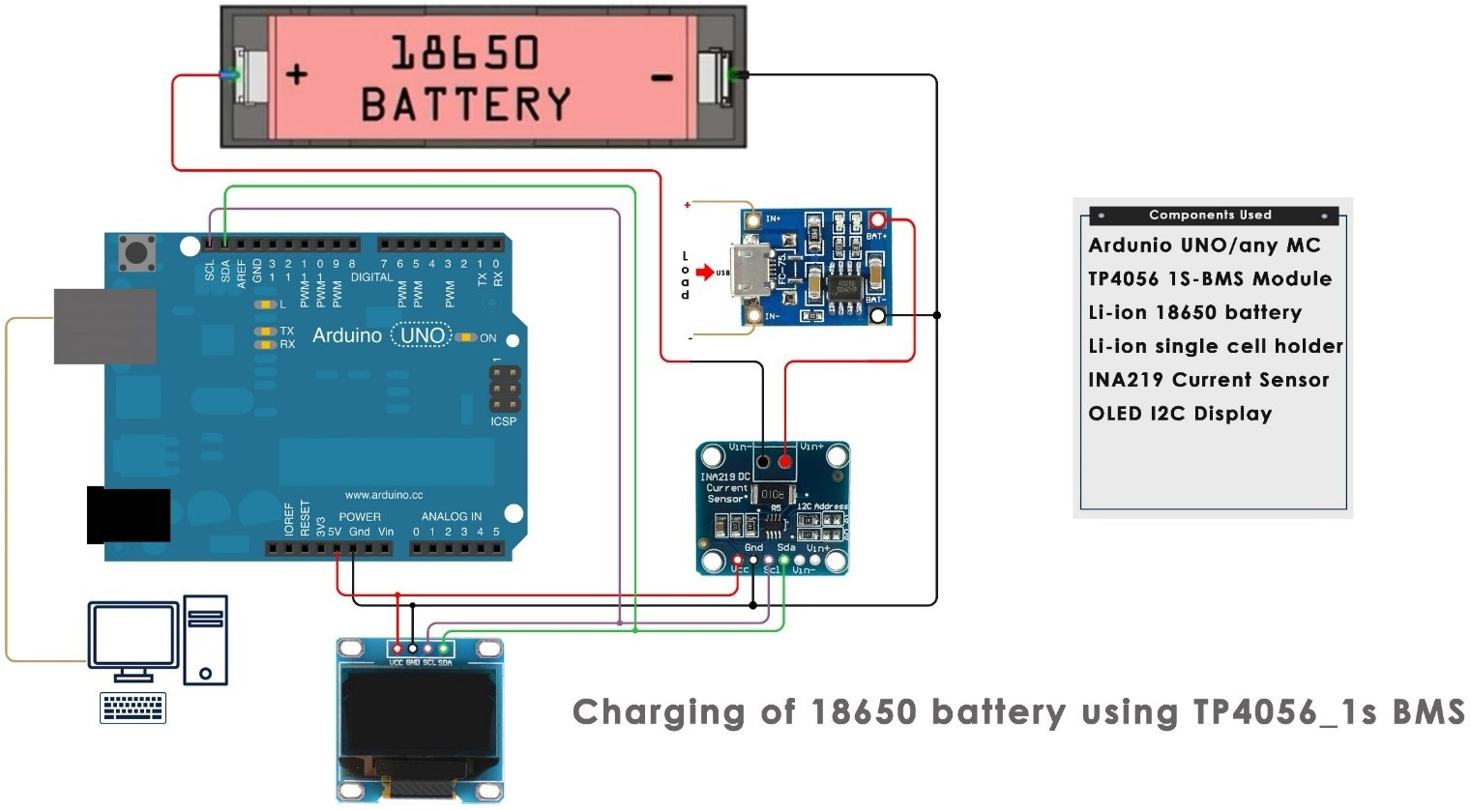

Figure: 1. Circuit diagram for 18650 charging system

Code: https://drive.google.com/file/d/1HyYRMwqKqtxfVCetkQ47HziZ5IECjNU8/view?usp=sharing Note: The code file only can accessed by using BITS email id.

Experimental results:

Sl.No | Time | Voltage | Current | Observations made
1.
2.
3.
4.
5.
6.
7.
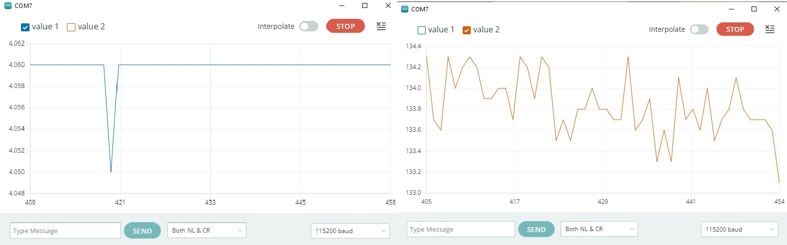

Result:



Charging of 18650 battery using 2S-BMS

Experiment No: 03
Aim: Charging of Samsung 18650 Li-ion cell by using double-cell BMS chip HX-2S-D20.

Software Required: Arduino IDE

Theory:

Battery Electric Vehicles (BEVs) are becoming ever more popular and in high demand. The most critical and costly element of the BEV is the battery system. In order to guarantee optimal performance, it is important to continually monitor the battery pack and the enclosed cells connected in series under all driving conditions and during battery charging.
The system with the monitoring and the development of the algorithm was a crucial role, so the system with monitoring states for various items like the voltage, temperature, coolant flow, current, the health of individual cells, and the state of balance of cells, were major aspects to look into. There are different types of BMSs that are used to avoid battery failures. The most common type is a battery monitoring system that records the key operational parameters such as voltage, current and the internal temperature of the battery along with the ambient temperature during charging and discharging. The system provides inputs to the protection devices so that the monitoring circuits could generate alarms and even disconnect the battery from the load or charger if any of the parameters exceed the values set by the safety zone parameters.
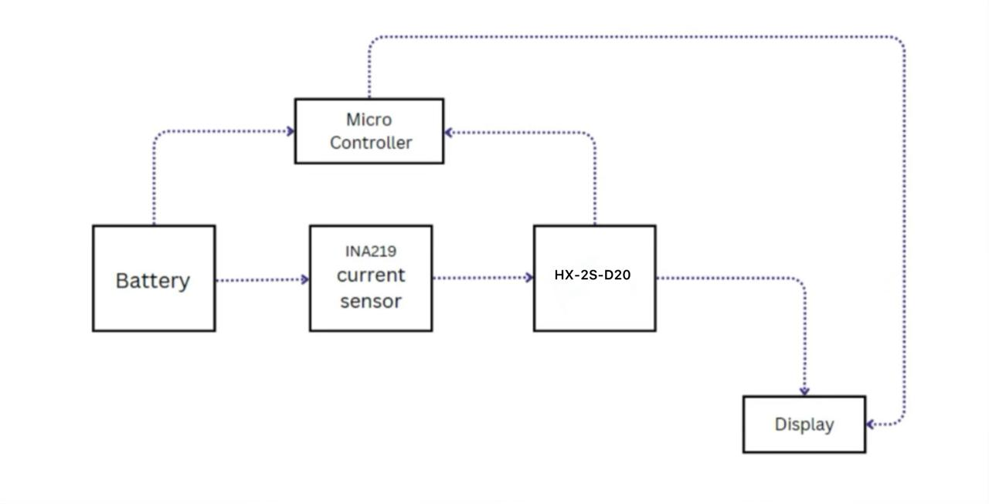
Figure: 2. Block diagram representation for 2S-BMS

Components required:

Sl.No | Component name | Qty | Link | Approx.  Price
1. | Arduino UNO/ NANO | 1 | Buy Original Arduino Nano made in Italy with 6  month brand Warranty (robu.in) | /1499
2. | CJMCU-219 INA219 I2C  Interface current sensor | 1 | Buy INA219 Bi-Directional Power Supply  Monitoring Module Online (robu.in) | 219
3. | 1.3 Inch I2C OLED Display  Module 4pin | 1 | Buy Best Quality 1.3 Inch I2C/IIC OLED LCD  Display Module 4pin- WHITE (robu.in) | 331
4. | 18650 SMD/SMT High-  Quality Single Battery Holder | 1 | Buy High Quality 18650 SMD Single Battery Holder at Low Price | Robu | 60
5. | TP4056 1A Li-ion Lithium Battery Charging Module With Current Protection –  Type C | 1 | Buy Li ion TP4056 Charging Board Type C w/ Current Protection (robu.in) | 26
6. | Samsung ICR18650-26JM 2600mAh (2C) LI-ION  BATTERY | 1 | Buy SAMSUNG 18650 26J 2600mAh Li ion  Battery Online | Robu.in | 353
7. | Type C cable | 1
8. | Connecting wires | 1 | Buy U - Shape Breadboard Jumper Kit - 140 Pcs  Online at the Best Price (robu.in) | 109
9. | Breadboard | 1 | Buy 400 Point Mini Breadboard Online at the  Best Price in India (robu.in) | 55

Circuit diagram:
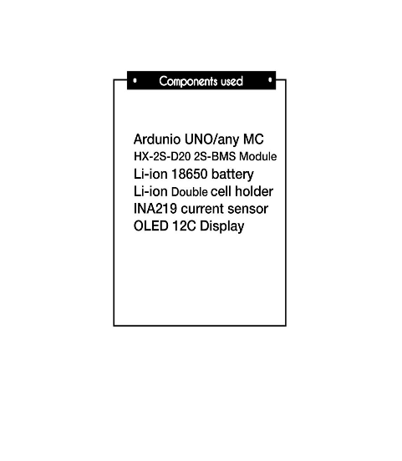

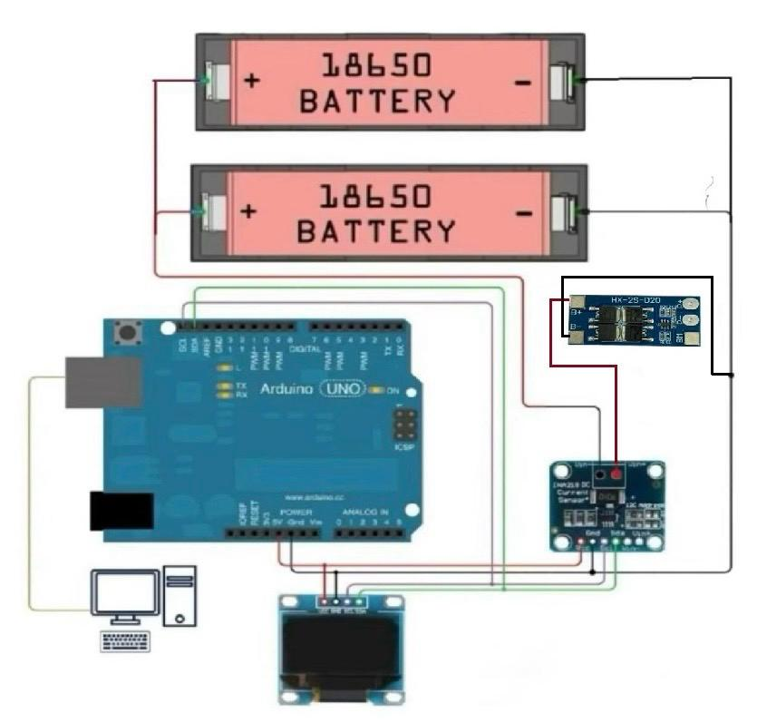

Figure: 1. Circuit diagram for 18650 charging system

Code: https://drive.google.com/file/d/1HyYRMwqKqtxfVCetkQ47HziZ5IECjNU8/view?usp=sharing Note: The code file only can accessed by using BITS email id.

Experimental results:

Sl.No | Time | Voltage | Current | Observations made
1.
2.
3.
4.
5.
6.
7.


Result:

